Sign up to Volunteer at
Gopher State LI (51)!!
Volunteer Sign-Up Form
www.gopherstateroundup.org/welcome/volunteer/
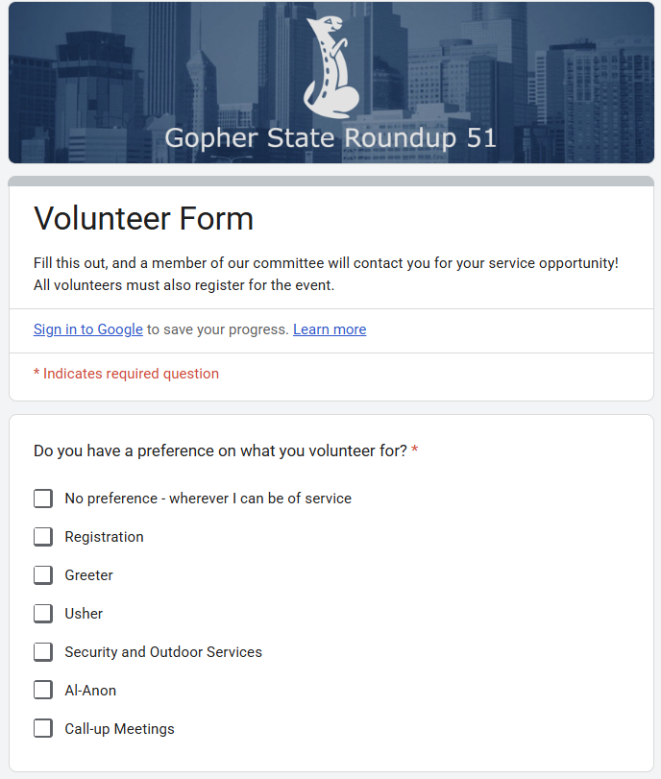

For further information or questions please contact the Executive Board
executivecommitteechair@gopherstateroundup.org

